Find **boards.txt** file

Mine is located at

C:\Users\PC\AppData\Local\Arduino15\packages\esp32\hardware\esp32\1.0.6

**PC** is the name of my computer.  
**AppData** folder is hidden by default, so you have to unhide this.  
1**.0.6** is the version of ESP32 I am using

Open **boards.txt** file in text editor and find the following lines.

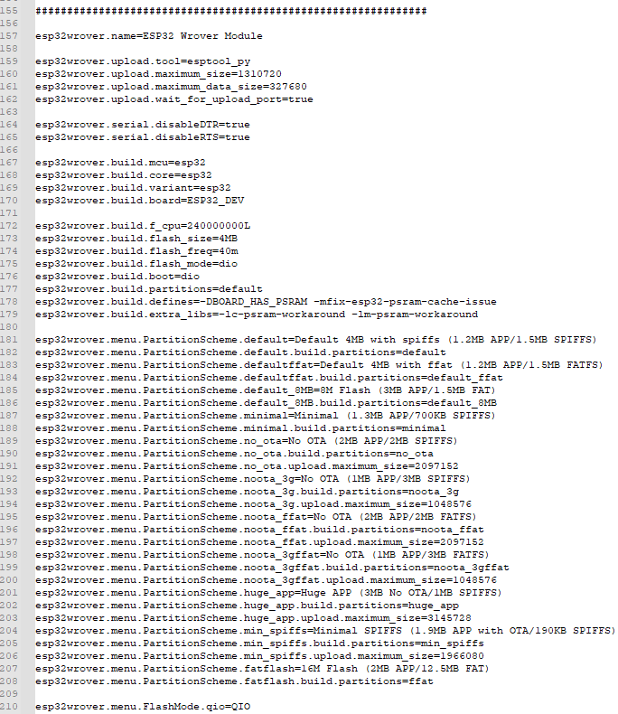

Add these three lines at the end

**esp32wrover.menu.PartitionScheme.large_spiffs=Prayer Partition (1.25MB APP/OTA/12.5MB SPIFFS)  
esp32wrover.menu.PartitionScheme.large_spiffs.build.partitions=prayer_partition  
esp32wrover.menu.PartitionScheme.large_spiffs.upload.maximum_size=13107200**

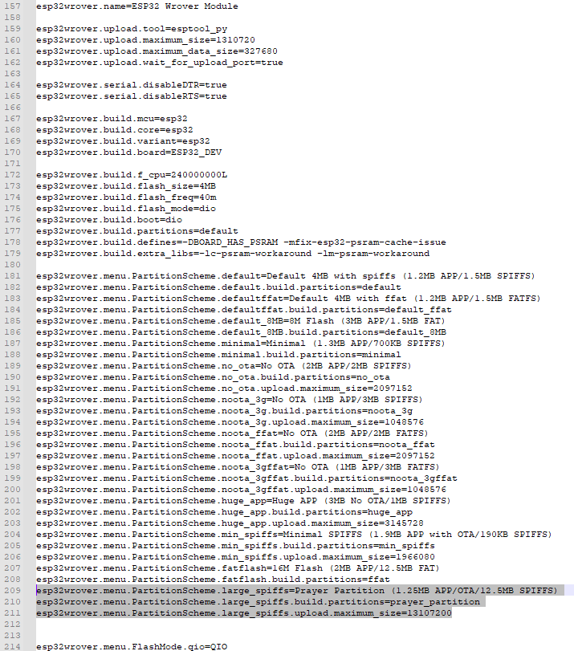

now go to this location and add this file **prayer_partition.csv**

C:\Users\PC\AppData\Local\Arduino15\packages\esp32\hardware\esp32\1.0.6\tools\partitions

**Before adding**

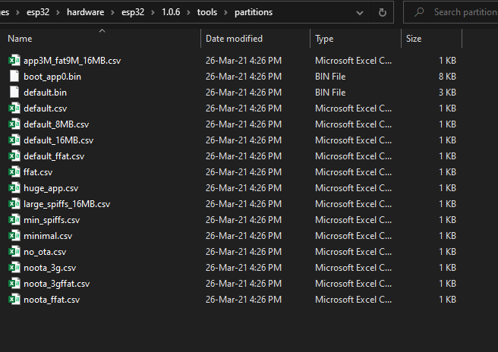

**After adding**

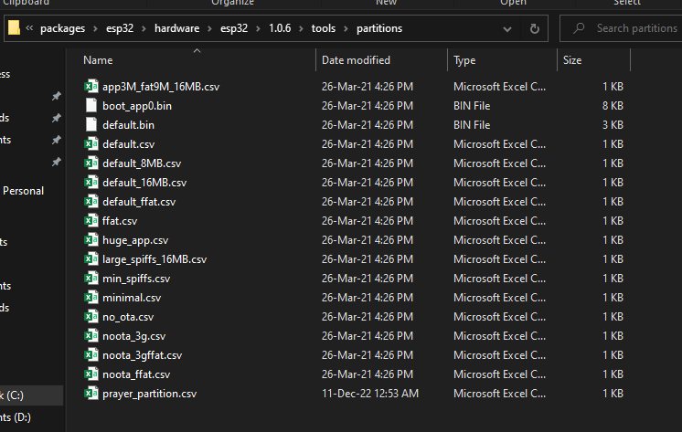

Restart Arduino IDE, connect ESP32 board

Now select board and partition in IDE under **tools**

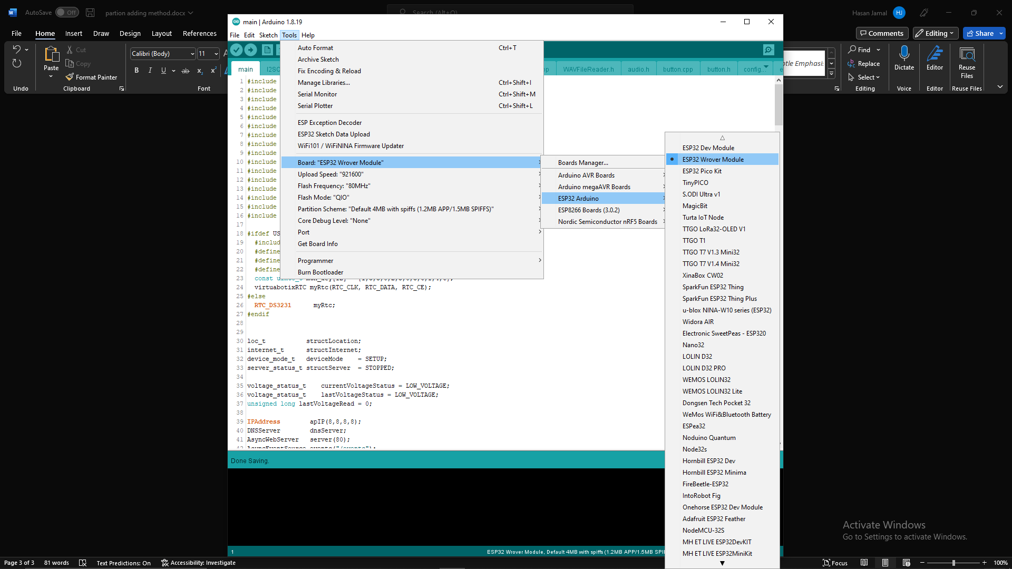

Select new added partition

Upload audio and web files in ESP32

Make sure Serial monitor is close now click on ESP32 Sketch Data Upload.

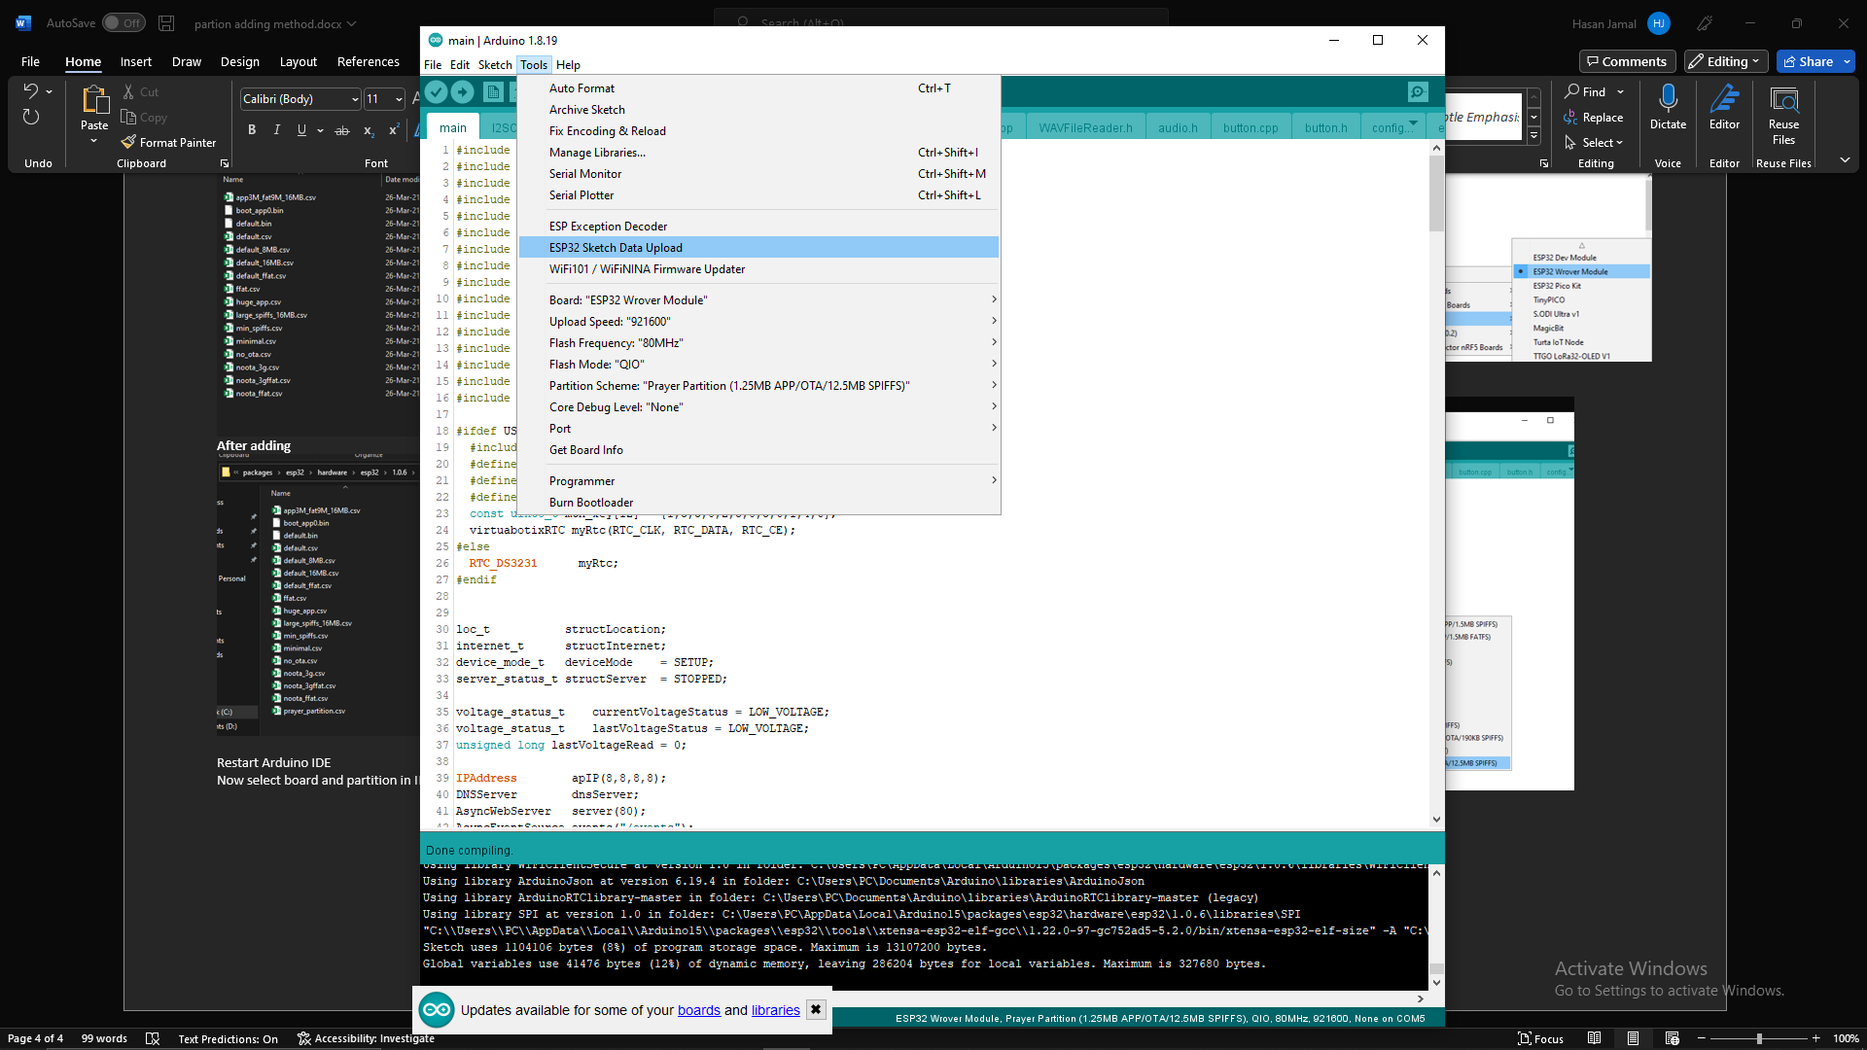

After successfully upload files in ESP32 now upload code in ESP32.

Click on upload button.

